Personal Religious Accommodation

To Whom It May Concern:
Under the guidance and ministration of the First Christ Ministry, practicing Christian values, and writing on the behalf of [BELIEVER_NAME] to confirm that his/her sincerely held religious beliefs prevent him/her from partaking in the administration and/or receiving a mandatory COVID-19 vaccination. Our ministry, for ourselves and our congregants, and all true Christian believers, in His name, affirms the that the right to request and receive religious accommodation with regards to any and all mandatory vaccination(s) or medical interventions requested or required by governmental authorities and/or employers. Our ministry has also issued an official statement confirming this right according to doctrinal standards and scripture which has been attached to this accommodation request.
After a private and personal one-on-one life counseling session, it has been determined that [BELIEVER_NAME]’s request for religious accommodation is of bona fide religious conviction cemented with his/her sincerely held religious belief in His name and is aligned with our official ministerial statement regarding medical interventions, doctrinal standards, and scripture regarding accommodation.
We appreciate your understanding in this matter.
Sincerely,
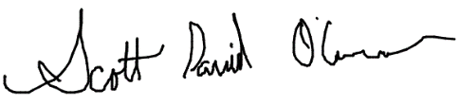
Scott David O’Connor, Minister
First Christ Ministry

